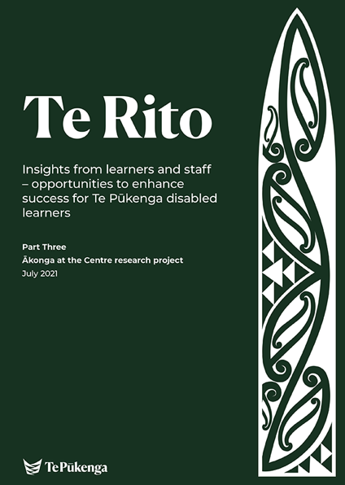

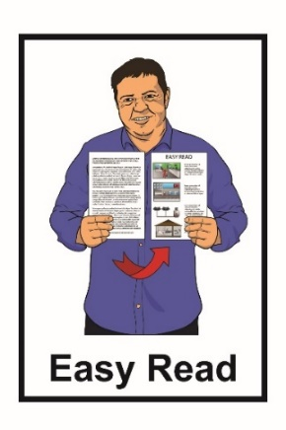

Things we have found out from disabled learners and support staff

In this report

Page number:

About this report 2

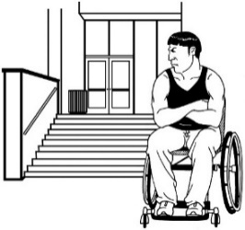

Barriers we found 7

What actions should happen next? 22

About this report
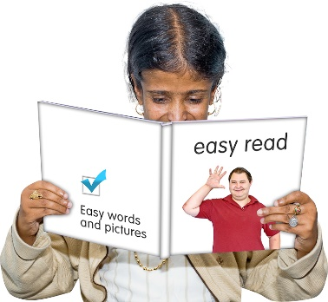

This Easy Read report is by Te Pūkenga New Zealand Institute of Skills and Technology.

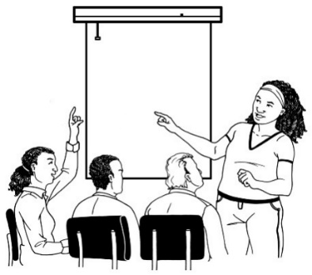
Te Pūkenga New Zealand Institute of Skills and Technology is a place that does vocational education across New Zealand.

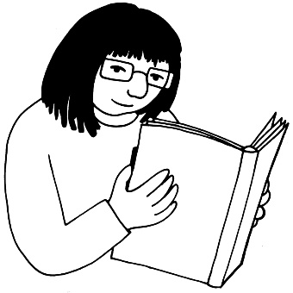

Vocational education is learning that gets you ready to work in a job.

In this document we call Te Pūkenga New Zealand Institute of Skills and Technology Te Pūkenga.

This report is about the things we found from:

- disabled people who have been learning at Te Pūkenga

- staff who have been supporting disabled people with their learning at Te Pūkenga.

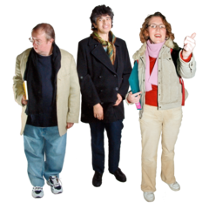

In this report we call disabled people who are learning disabled learners.

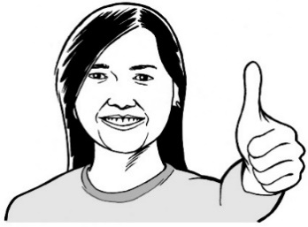
Thank you to everyone who told us about what vocational education is like for disabled learners in Aotearoa.

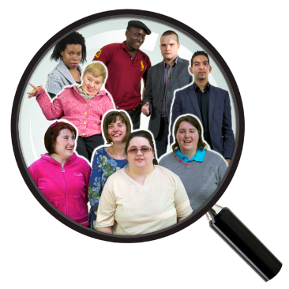
We have used what people told us to find out:
- what the barriers are for disabled learners
- how things can be done better.

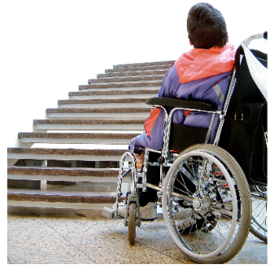
Barriers are things that make it harder for disabled people to have good lives like everyone else.

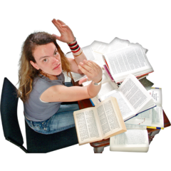
Vocational education can be very hard for disabled people because they do not get the support they need.

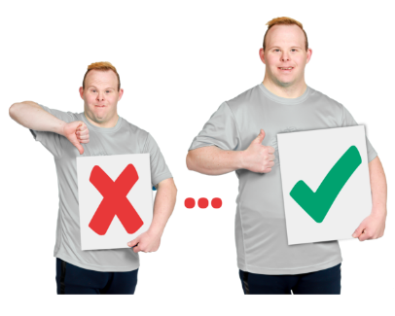
Te Pūkenga can do better for disabled learners if we:
- listen to what has been said by
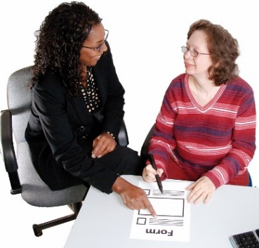
  - disabled learners
  - support staff
- act to change things.

Disabled learners have told us that when they get the right learning support it makes a very big difference to:
- how well they do in their courses
- their whole life.

Disabled learners who get the right support are just as likely to finish their
post-secondary qualifications as people who are not disabled.

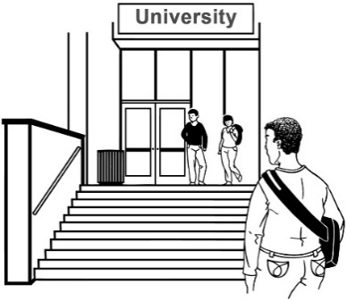
Post-secondary means study you do after high school / college.

Post-secondary is also sometimes called tertiary.

A qualification is what you get to show you have done the study like a:
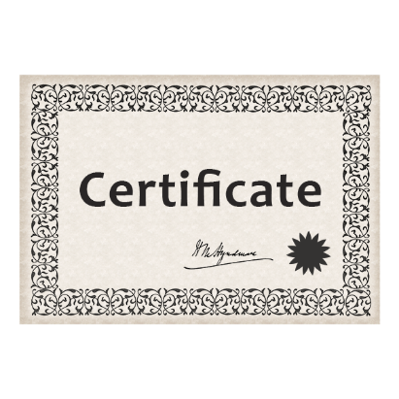
- degree
- diploma
- certificate.

Barriers we found

Barrier 1: People who work at the place of learning do not know enough about disability.

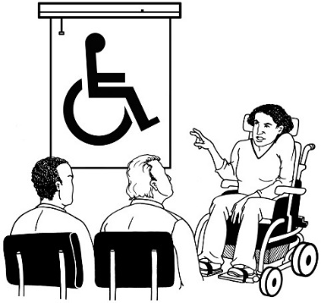
Some ways to take this barrier away are:
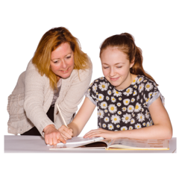
- staff understanding the barriers disabled learners face
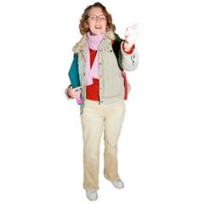
- staff supporting disabled students by working in a way that includes their needs
- staff understanding why vocational education is a good thing for disabled learners.

Barrier 2: Disabled learners do not get the right support.

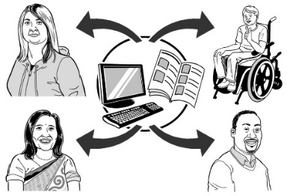
Some examples of this are learners:
- not having enough information about courses or learning support
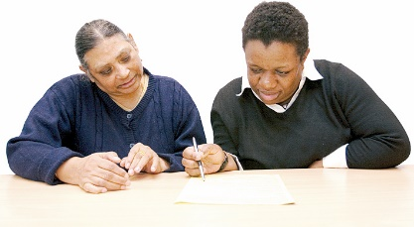
- getting learning support late
- not getting enough learning support with exams / tests
- not getting learning support because:
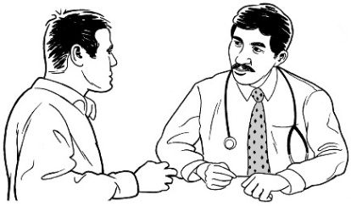
  - there is not enough money
  - they do not have a diagnosis.

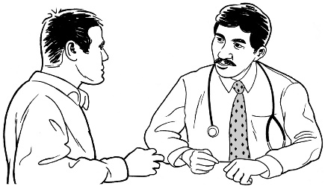
A diagnosis is when a doctor says you have a disability or health condition.

Sometimes getting a diagnosis can mean:

- having to do a lot of tests
- paying a lot of money.

Other problems are because of:

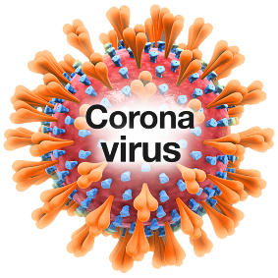
- Disability Support Services staff being too busy
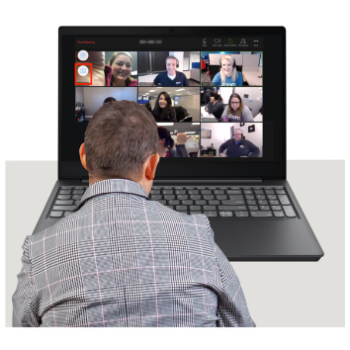
- the ways different learning places manage the problems caused by COVID-19
- problems with people learning online from home.

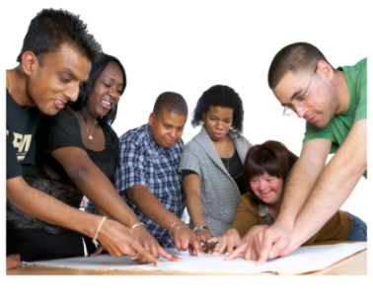
Some ways these barriers can be taken away are:
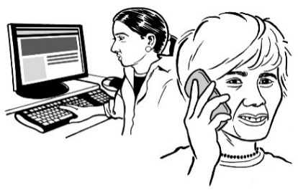
- all staff working to make sure disabled learners have support rather than Disability Support Staff doing everything
- staff talking to disabled learners when they sign up for study
- giving the right kinds of learning support
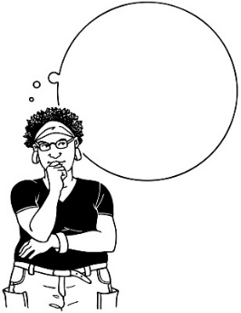
- looking at what a disabled learner is good at
- staff thinking the things disabled learners do well are important.

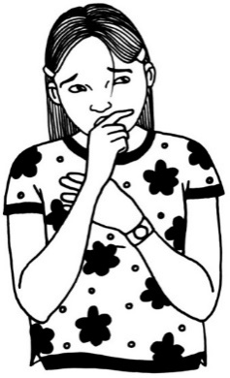
Barrier 3: Some disabled learners are scared to:
- be in touch with Disability Support Services
- tell anyone about their disability
- ask for support.

Sometimes disabled learners are scared because they:
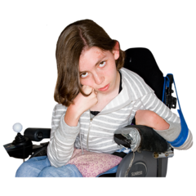
- were treated badly at school because of their disability
- are worried the same thing will happen again.

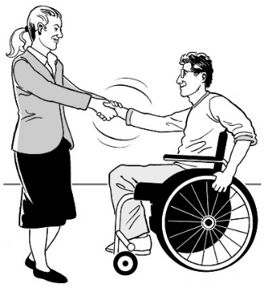

This barrier can be taken away by making it safe for disabled learners to talk about their disability.

Disabled learners are more likely to tell people about their impairment if they know:
- why they are being asked for the information
- what the information will be used for.

Barrier 4: Some disabled learners feel overwhelmed.

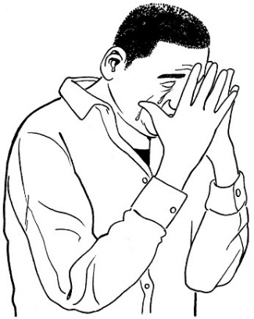
Overwhelmed is when:
- there is too much to do or the things you have to do seem hard
- you find it hard to cope.

This is harder for learners when they do not have support from peers.

Peers are people who are also learning in the same vocational education course.

Some ways to take away this barrier are:
- giving more support to learners who:
  - have mental health issues
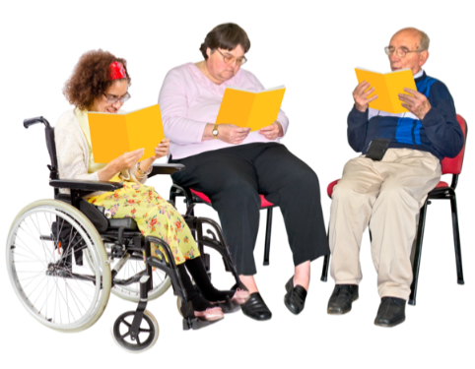
  - are finding things hard
- staff putting in place peer support.

Peer support is when learners support each other.

Barrier 5: There is not enough money for learning support.

Some students also do not have enough money to live on.

Some ways to take this barrier away are:
- having more money for learning support for learners with high support needs
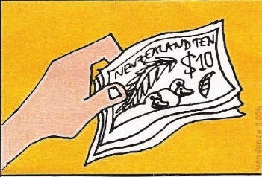
- supporting disabled learners with course fees and things they need to buy for their study
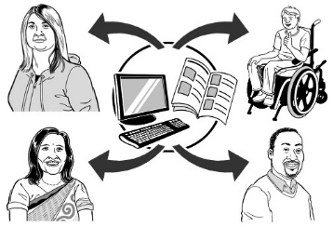
- giving more information about money so disabled learners can make better decisions about studying.

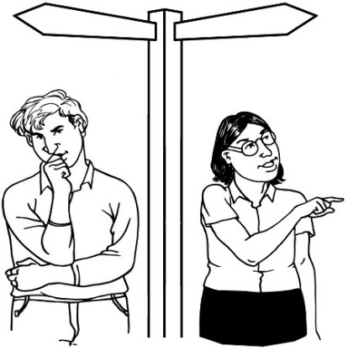
Barrier 6: Disabled learners do not have enough:
- employment pathways
- academic pathways.

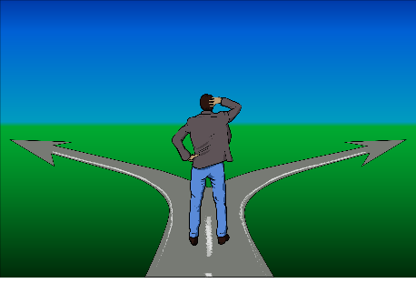

Pathways are like plans for the kind of learning people can do.
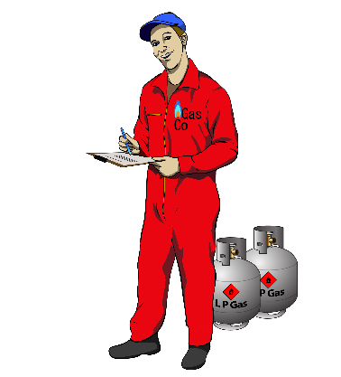

Employment pathways show people how to get to different jobs.

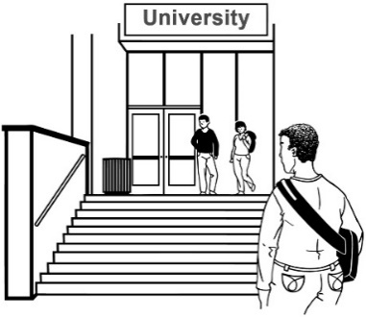
Academic pathways show people how to get to more study.

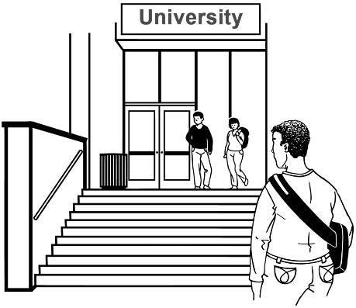
Some ways we can solve these barriers are:
- removing the barriers that stop some disabled learners choosing academic pathways
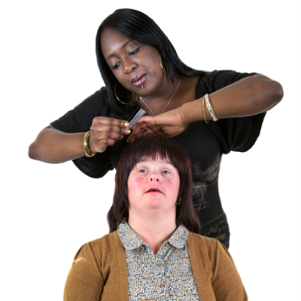
- making more employment pathways with:
  - internships
  - work placements.

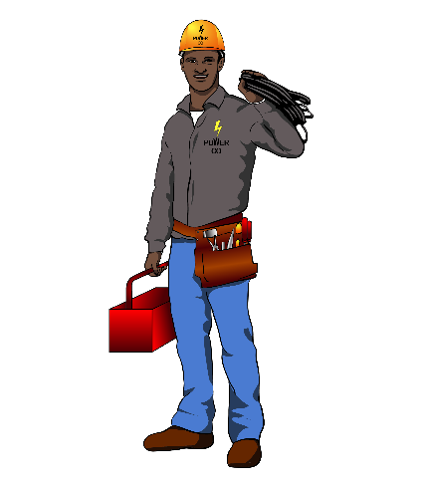

Internships are where you learn how to do a job by having a job where you are trained as you work.

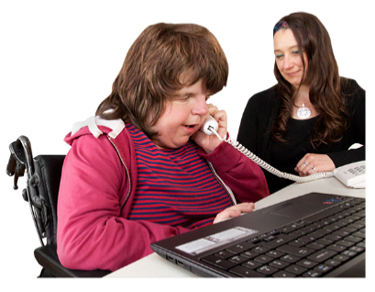
Work placements are when your education provider sends you to spend some of the course working to learn more about the jobs you can do.

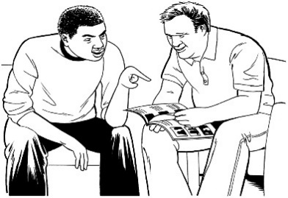
Barrier 7: Information for learners is not accessible.

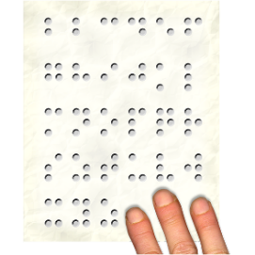
Information is often not in accessible formats like:
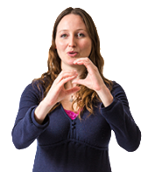
- Easy Read
- braille
- New Zealand Sign Language.

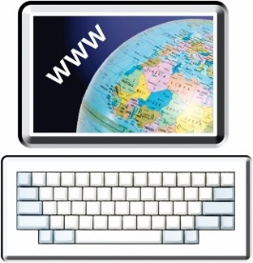
Websites are often not made in ways all disabled people can use.

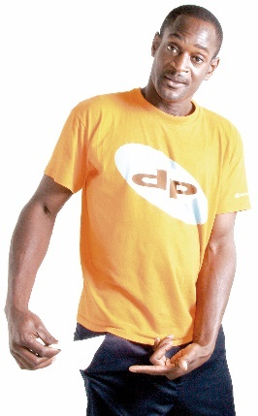
Some students do not have enough money for:
- computers
- internet.

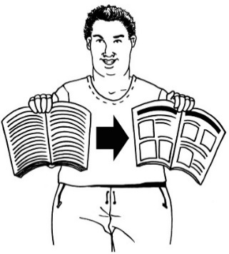
Some of the ways we can solve these barriers are:

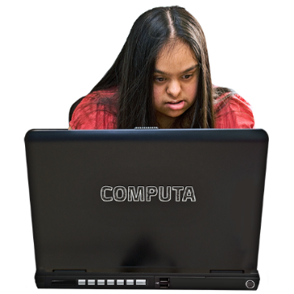
- knowing that some disabled learners need to get information in accessible formats
- supporting all disabled learners to learn more about using computers.

Barrier 8: The place people learn can sometimes be a problem.

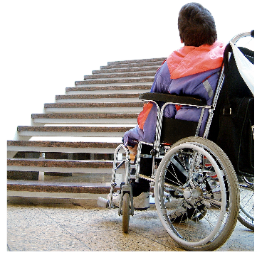
For example it might have:
- heavy doors
- paths on steep hills
- steps to get into buildings.

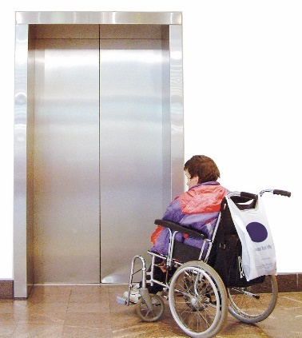
Some disabled people have problems using lifts.

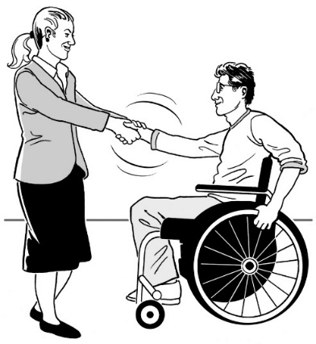
Some ways to fix this barrier are:
- disabled learners visiting before their course starts to find out:
  - the best ways around
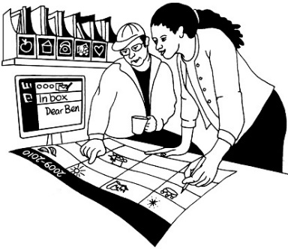
  - if there are any barriers
- working together with disabled learners and support staff to make a plan for making the place they learn accessible for disabled learners
- putting money aside every year to work on the things in the plan
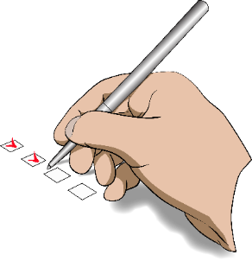
- checking
  - how things are going
  - if there are new problems.

What actions should happen next?
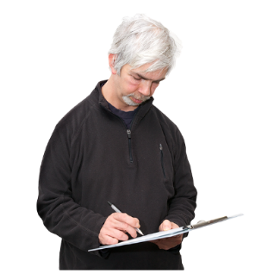

Actions are things that need to happen to make things better for disabled learners.

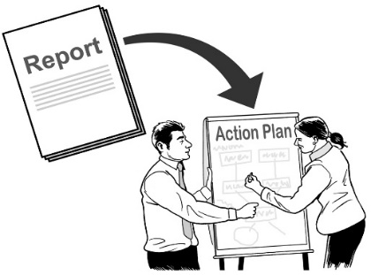
Action 1:
Toolkit

Make Disability Action Plans.

Disability Action Plans are lists of things that vocational education providers will do to make their places of learning better for disabled learners.

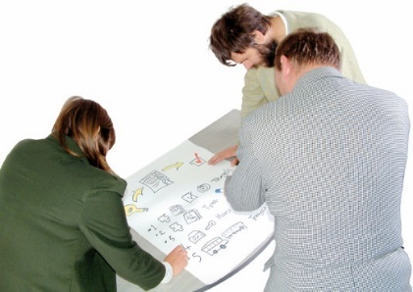
Disability Action Plans should be made by working together with disabled learners who have different disabilities.

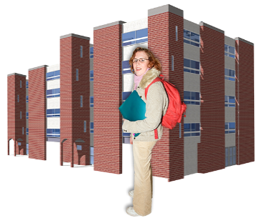
Vocational education providers should work together with disabled learners on the review of:
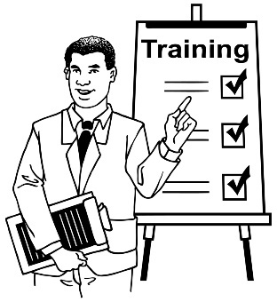
- buildings
- what is in the courses
- how the courses are taught
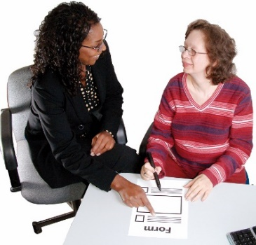
- how learners get information
- learning support.

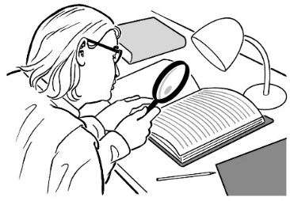
Review means to:
- look at something again
- see if changes are needed.

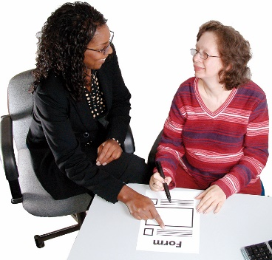
Action 2:

Put things in place for supporting disabled learners across all vocational education providers.

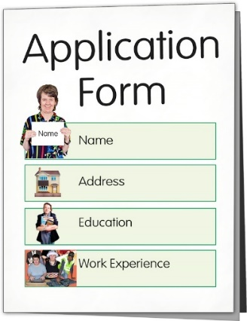
Action 3:

All education providers should ask people starting course questions to find out if they disability support.

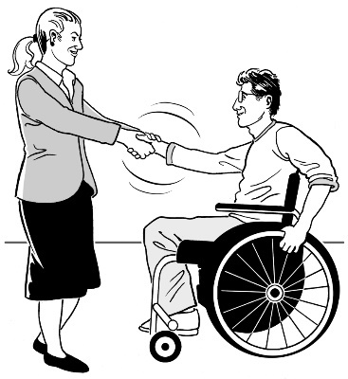

Work to make sure it is safe for learners to tell people about their support needs.

Action 4:
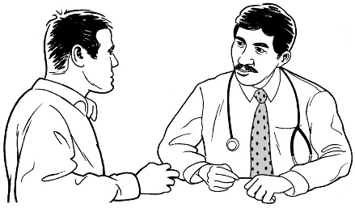

Review whether disabled learners need to have to have a diagnosis from their doctor if it is already clear they have learning support needs.

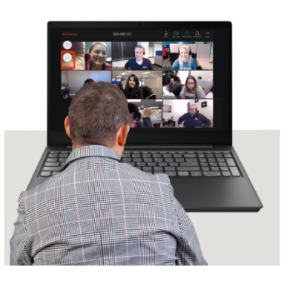

Action 5:

Write down how staff should support disabled learners with learning on the internet.
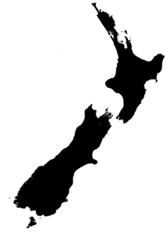

This should happen for the whole of New Zealand.

Action 6:

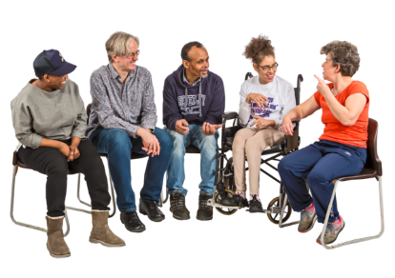
Make it so all education providers have to:

- set up groups that represent disabled students
- work together with those groups.

Action 7:

Review how things are set up to pay for learning support for people with high support needs.

Action 8:

Make an agreement to send lots of learners to one place to get a:
- diagnosis
- assessment.

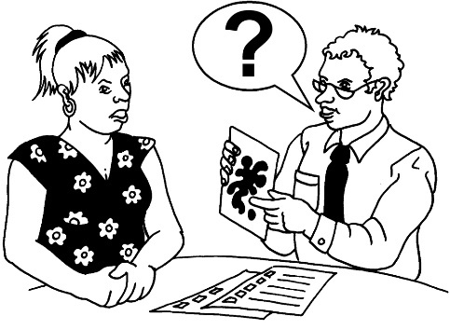
An assessment is a way of looking at what a disabled learner:
- can do
- finds it hard to do
- needs to support their learning.

Sending lots of learners to the same place will be a way of making it cheaper to get these.

Action 9:
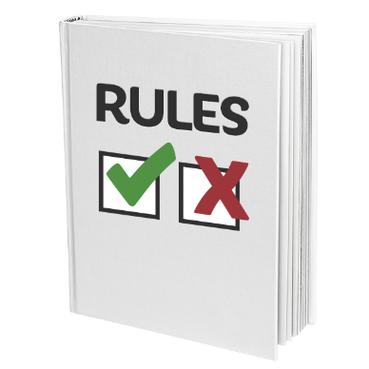
Make rules so disabled learners do not have a harder time with money if:
- they study part time
- an impairment means they:
  - need to stop doing some of their classes
  - do not pass some of their classes.

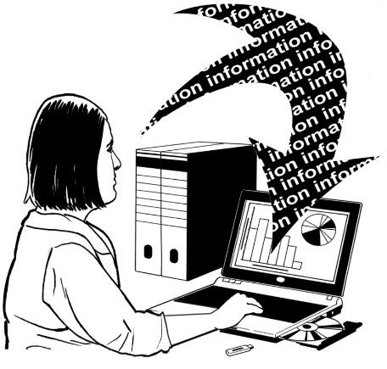
Action 10:

Work on getting more information about disabled learners who have different kinds of impairments.

Action 11:

All providers should have to do the things in the Accessibility Charter.

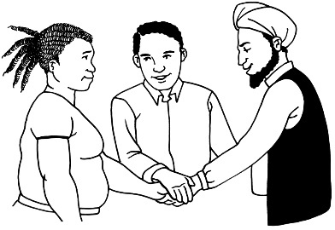
The Accessibility Charter is written by the Ministry of Social Development
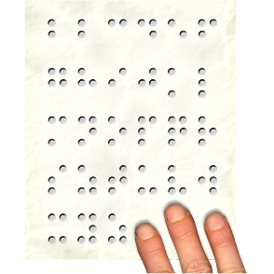
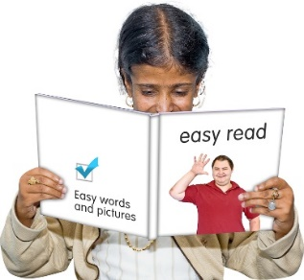
The Accessibility Charter is an agreement about:
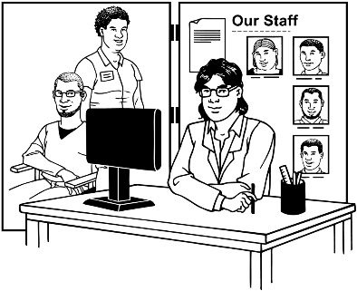
- having government information available in ways that everyone can understand

- making government services available in ways that work for everyone.

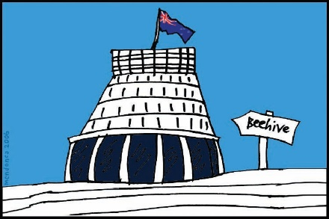
Some government agencies have signed up to follow the Accessibility charter.

Action 12:
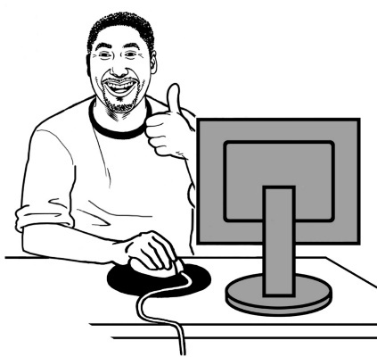

Make plans for:
- improving how well learners can use computers
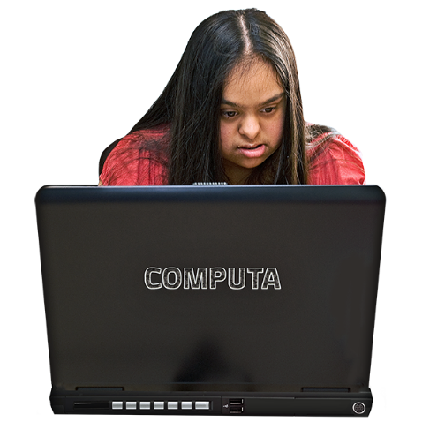
- making sure disabled learners can get:
  - computers
  - internet.

Action 13:
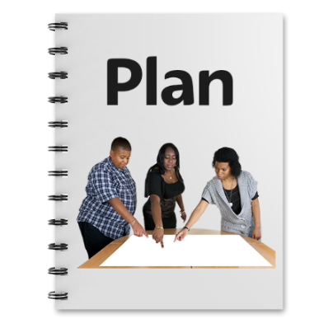

Make all vocational education providers:
- make a physical access plan
- keep checking how good their physical access is
- put aside money to make physical access better.

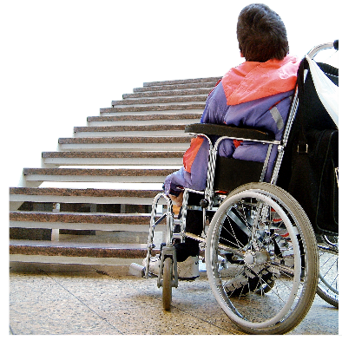
Physical access means things like how well disabled people can:
- get into the buildings
- move around in the buildings
- get between different buildings.

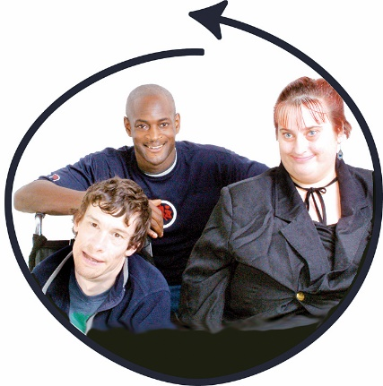
This work should be done together with:
- disabled learners
- disability support staff.

Action 14:

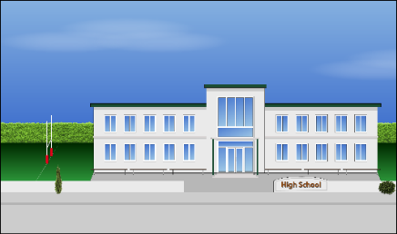
Tell the Ministry of Education they should find ways to solve the problems many disabled learners had at high school / college.

One way of doing this would be to make all schools have a Disability Action Plan.

This information has been written by Te Pūkenga.
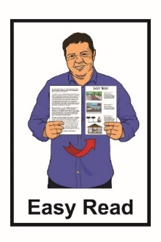
It has been translated into Easy Read by the Make It Easy service of People First New Zealand Inc. Ngā Tāngata Tuatahi.

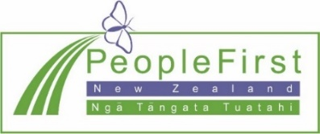
The ideas in this document are not the ideas of People First New Zealand Inc. Ngā Tāngata Tuatahi.

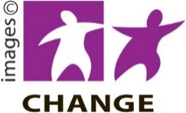
Make It Easy uses images from:

- Changepeople.org
- Photosymbols.com

- Sam Corliss

- Huriana Kopeke-Te Aho

All images used in this Easy Read document are subject to copyright rules and cannot be used without permission

